ServiceNow Project Documentation

Introduction
- Project Title: Import Data Using Transform Maps in ServiceNow
- Team Members:
Kalaiveni K
Thanuja P
Anitha C
Harini S
Project Overview :
- Purpose: The project imports structured employee data from an external spreadsheet into ServiceNowusing Import Sets and Transform Maps.
- Features: Import spreadsheet data, create an Import Set table, map source and target fields, transformrecords, prevent duplicates using Coalesce, and display information through Reports and Dashboards.

Architecture
- ServiceNow: The complete project is configured within the ServiceNow platform.
- Data Source: Excel/Google Spreadsheet containing employee information.
- Import Set: Employee Import (u_employee_import) acts as the staging area.
- Transform Map: Maps Employee ID, Employee Name, Email, Department and Location to the target table.
- Target Table: Employee Test (u_employee_test) stores the transformed employee records.
- Reporting Layer: Reports and Employee Analytics Dashboard provide centralized visibility.

Setup Instructions
- Prerequisites: ServiceNow instance, appropriate access, and an Excel/Google Spreadsheet containingstructured employee data.
- Installation: Create Employee Test table and fields; create Employee Import table; load the spreadsheetusing Load Data; create the Transform Map; configure field mappings; save and run the transformation; configure Coalesce on Employee ID.

Folder Structure
- ServiceNow Project: The project is configured inside ServiceNow rather than using a MERN client/serverfolder structure.
- Data Source: Employee spreadsheet.
- Import Set: Employee Import.
- Target Table: Employee Test.
- Transform Map: Sample Spreadsheet Import.
- Reports: Employees by Department, Employees by Location and Employee List Report.
- Dashboard: Employee Analytics Dashboard.

Running the Application
- Open the ServiceNow instance and navigate to Load Data.
- Select the Excel file and load it into Employee Import.
- Open the Transform Map and run Transform.
- Verify the transformation status and records in Employee Test.
- Open Reports and the Employee Analytics Dashboard to view the results.

API Documentation
- The project does not expose a custom REST API. The core workflow uses native ServiceNow Import Setand Transform Map functionality.
- Document any ServiceNow API endpoints only if they are added to the implementation.

Authentication
- Users require valid ServiceNow credentials and appropriate roles or permissions to access the requiredtables, Import Sets, Transform Maps, Reports and Dashboards.
- Administrative permissions may be required for certain configuration operations.

User Interface
• Provide screenshots showcasing the Employee Test table, Load Data screen, Transform Map and field
mappings, Transform History, Reports and Employee Analytics Dashboard.

Testing
- Test spreadsheet upload into the Import Set.
- Test source-to-target field mapping.
- Test successful transformation and record creation.
- Test Coalesce using an existing Employee ID with changed values.
- Test repeated imports to confirm duplicate prevention.
- Test Reports and Dashboard output.

Screenshots or Demo

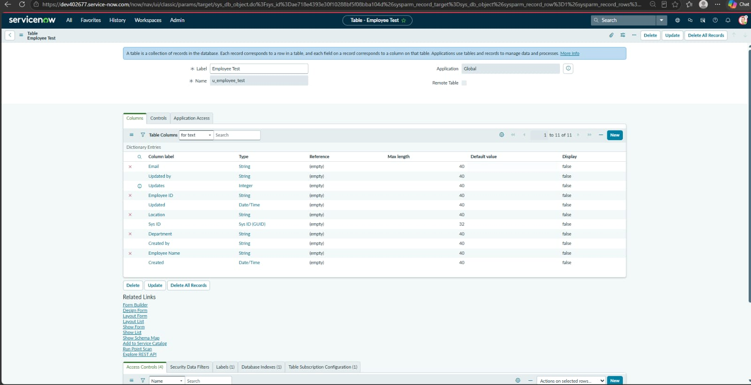
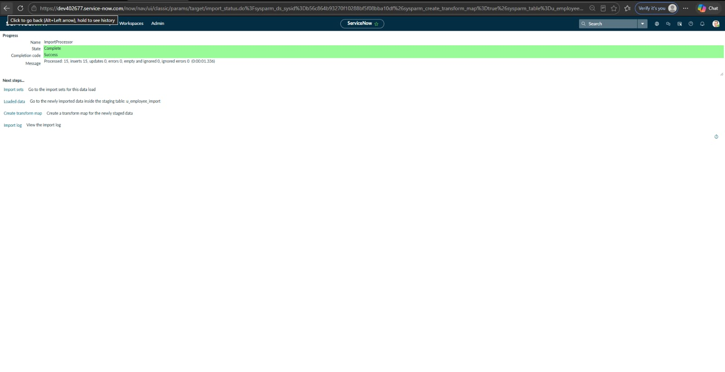

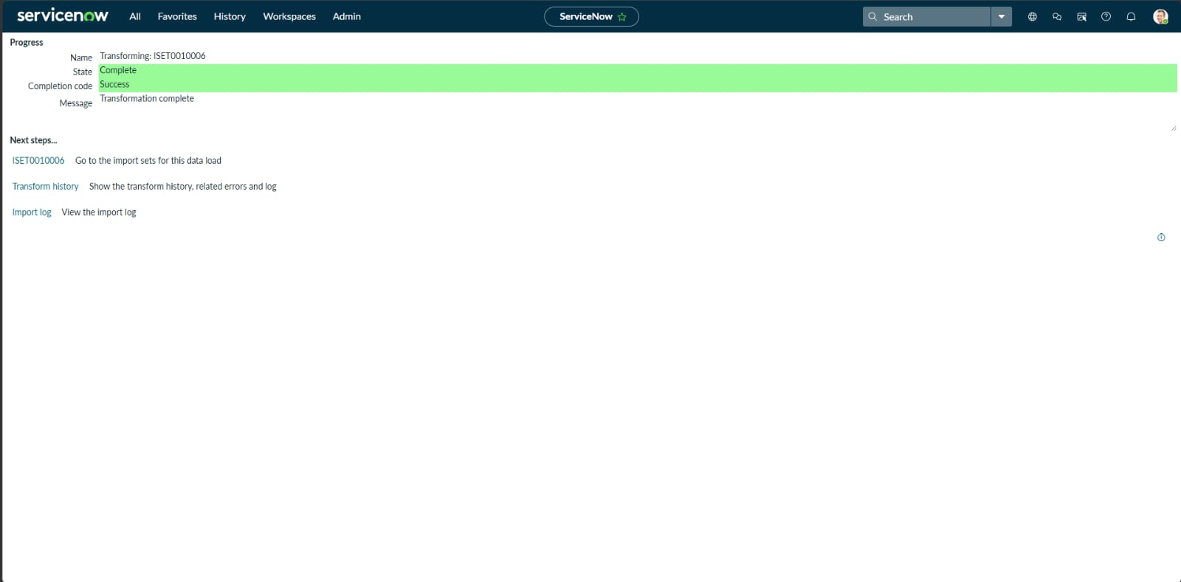

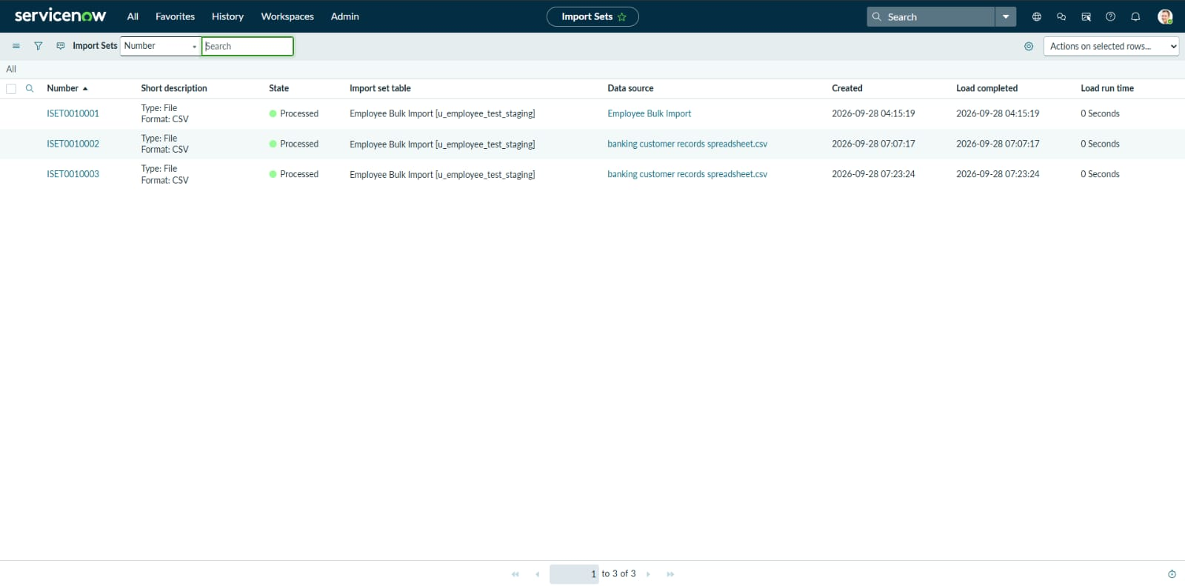

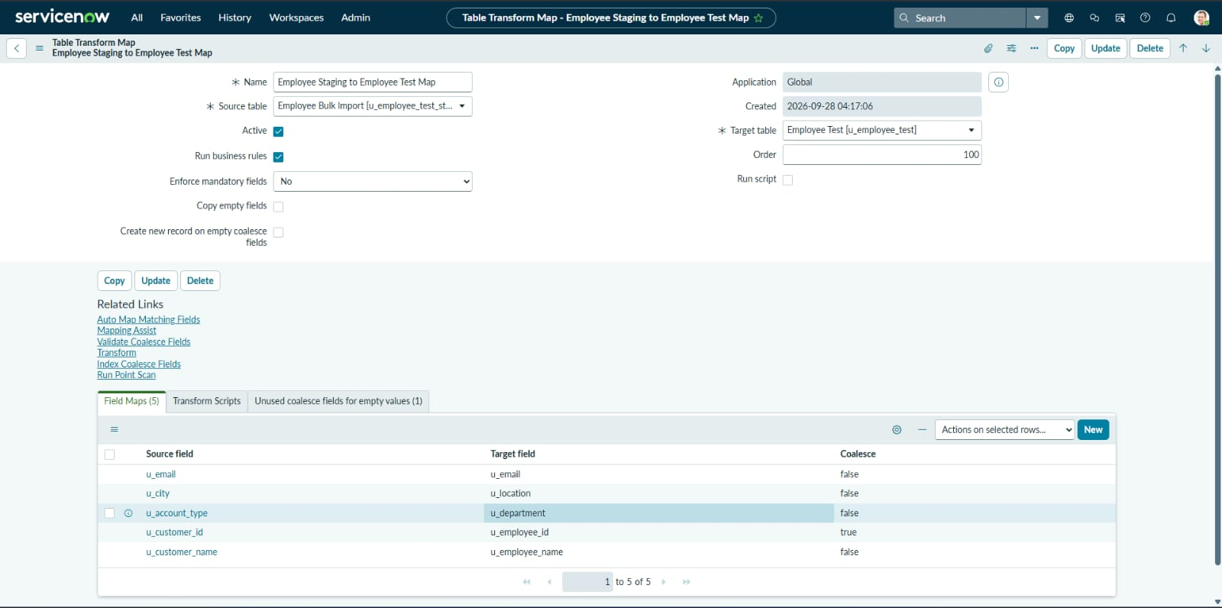

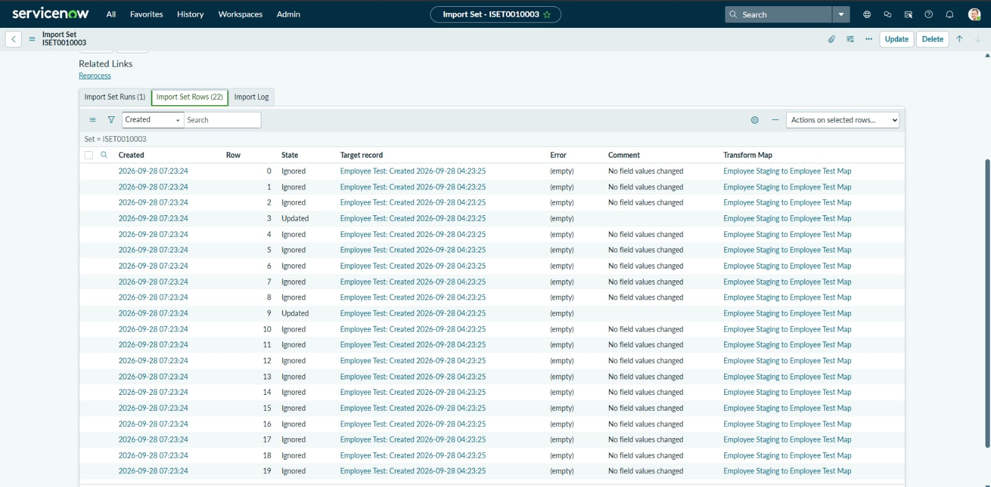

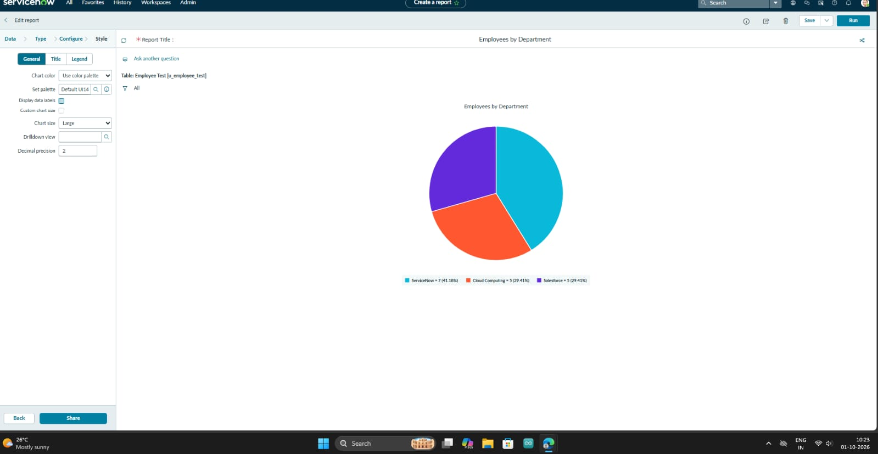

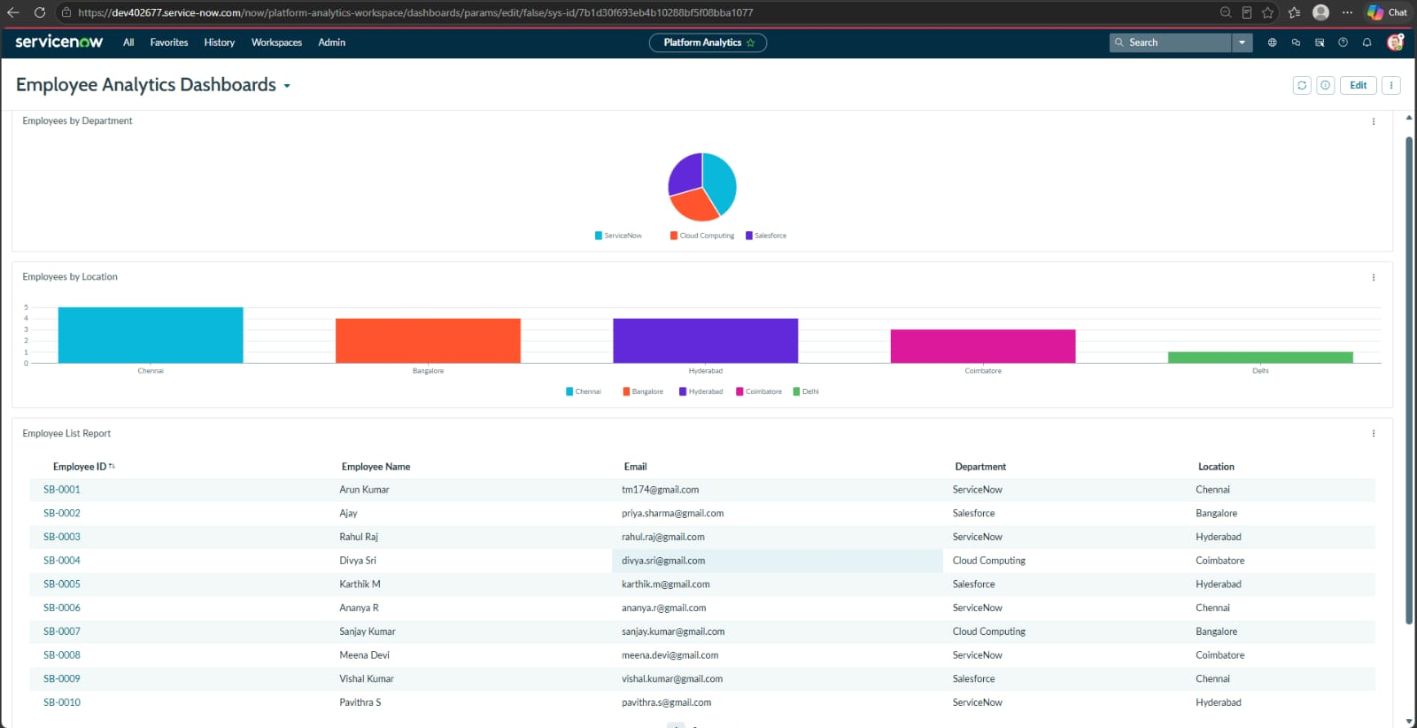

https://drive.google.com/file/d/1bYacbJKLNirJWDXSezjlbTLQlhgUXU66/view?usp=sharing

Known Issues
- Spreadsheet data must follow the expected column structure.
- Incorrect field mappings may cause inaccurate imported records.
- Required ServiceNow permissions are needed for configuration and dashboard operations.
- Large or inconsistent source files may require additional data validation.

Future Enhancements
- Schedule automatic spreadsheet imports.
- Add advanced data validation and error reporting.
- Add more employee analytics and import-performance metrics to the dashboard.
- Integrate additional external data sources.
- Implement more detailed role-based access controls.

